**Face Detection & Recognition using Image Processing for the Visually Challenged**

*A Part of Thesis (Project Phase-I) Submitted in Partial Fulfillment of the Requirements*

*for the Degree of*

Bachelor of Engineering

in Computer Science and Engineering

of

Assam Science and Technology University

*SUBMITTED BY*

Dipto Ghosh

Roll no.: 172010007013

Department of Computer Science and Engineering



Under the Guidance of

Ms. Jayashree Das,

Head of Department, CSE

Department of Computer Science and Engineering

Barak Valley Engineering College

Nirala, Karimganj, 788701

Assam, India

March, 2021

**ACKNOWLEDGEMENT**

We are greatly honoured to acknowledge and express our gratitude to our project mentor Ms. Jayashree Das who has been at our back and call during the entirety of the project and under whose auspicious guidance the project has been compiled. We also extend our heartfelt gratitude to all the Faculties of the department of Computer Science and Engineering of Barak Valley Engineering College, Karimganj, for giving us such a wonderful opportunity to expand our knowledge and motivating and encouraging us throughout the entire journey of preparing the project.

Date: 11/03/21

Place: Barak Valley Engineering College

Dipto Ghosh

**ABSTRACT**

*Human face detection and recognition play important roles in many applications such as video surveillance and face image database management. In our project, the face recognition is aimed for the visually challenged people. Visually challenged people face lot of problems in day-to-day life. Our goal is to make them lead a life which is of security and safety for their own wellbeing. This makes them confident to lead their life normally. The face detection helps them to recognize faces of people known to them within a certain distance. This project reduces the difficulty in identifying face of the person used.*

i

**AIM OF THE PROJECT**

To design a software model to help the visually challenged people for proper detection and recognition of people’s face with the help of image processing.

ii

**OBJECTIVE OF THE PROJECT**

The main objective of the project is to design a face detection and recognition system that can be helpful to the visually impaired people for identifying and recognizing a known person’s face. The system is required to collect relevant data and store it for future cross-matching of a subject’s face and revealing the knowledge regarding the identity of the person through a voice aided process.

iii

**CHALLENGES TO THE PROJECT**

**Illumination:** The slight change in lighting conditions cause a significant challenge for automated face recognition and can have a significant impact on its results. If the illumination tends to vary, the same individual gets captured with the same sensor and with an almost identical facial expression and pose, the results that emerge may appear quite different. Illumination changes the face appearance drastically. It has been found that the difference between two same faces with different illuminations is higher than two different faces taken under same illumination.

**Occlusion:** Occlusion occurs when one or other parts of the face are blocked and whole face is not available as an input image. Occlusion is considered one of the most critical challenges in face recognition system. It occurs due to beard, moustache, accessories (goggle, cap, mask, etc.), and it is prevalent in real-world scenario. The presence of such components makes the subject diverse and hence making automated face recognition process a tough nut to crack.

**Expressions:** Different expressions of the same individual are another significant factor that needs to be taken into account. Human expressions are particularly macro-expressions which are happiness, sadness, anger, disgust, fear, surprise. Micro-expressions are the one which shows the rapid facial patterns and happen involuntarily. Macro and micro expressions find their place on someone's face due to changes in one's emotional state and in the wake of such emotions- which are many- the efficient recognition becomes difficult.

**Pose:** Facial Recognition systems are highly sensitive to pose variations. The pose of a face varies when the head movement and viewing angle of the person changes. The movements of head or differing POV of a camera can invariably cause changes in face appearance and generate intra‐class variations making automated face recognition rates drop drastically. It becomes a challenge to identify the real face when the rotation angle goes higher. It may result in faulty recognition or no recognition if the database only has the frontal view of the face.

**Low Resolution:** The minimum resolution for any standard image should be 16*16. The picture with the resolution less than 16*16 is called the low-resolution image. These low-resolution images can be found through small scale standalone cameras like CCTV cameras in streets, ATM cameras, supermarket security cameras. These cameras can capture a small part of the human face area and as the camera is not very close to face, they can only capture the face region of less than 16*16. Such a low-resolution image doesn’t provide much information as most of them are lost. It can be a big challenge in the process of recognizing the faces.

**Ageing:** Face appearance/texture changes over a period of time and reflect as ageing, which is yet another challenge in facial recognition system. With the increasing age, the human face features, shapes/lines, and other aspects also change. It is done for visual observation and image retrieval after a long period. For accuracy checking, the dataset for a different age group of people over a period of time is calculated. Here, the recognition process depends on feature extraction, basic features like wrinkles, marks, eyebrows, hairstyles, etc.

**Model Complexity:** Existing state-of-the-art facial recognition methods rely on ‘too-deep’ Convolutional Neural Network (CNN) architecture which is very complex and unsuitable for real-time performance on embedded devices.

iv

**LIST OF FIGURES**

Fig. 1: Fundamental steps involved in Digital Image Processing.

Fig. 2: Sequential process involved in Viola Jones Algorithm.

Fig. 3: Diagrammatic sequence of the methodology.

Fig. 4.1: Data collected initially stored in local folder.

Fig. 4.2: Testing image matching with training image, revealing identity of the person as the local folder name storing the training images.

Fig. 4.3: The identity outputted in a speech format.

v

**SYSTEM REQUIREMENT SPECIFICATION**

**HARDWARE REQUIREMENTS:**

Operating System

* Windows 10

Processor

* Any Intel x86-64 processor

Disk

* Minimum 2 MB of HDD space for Data collection.
* Maximum 10 MB of HDD space post-testing.

RAM

* 8 GB DDR4 RAM.

**SOFTWARE REQUIREMENTS:**

**MATLAB**

Introduction

The name MATLAB stands for MATrix LABoratory. MATLAB was written originally to provide easy access to matrix software developed by the LINPACK (linear system package) and EISPACK (Eigen system package) projects. MATLAB is a high-performance language for technical computing. It integrates computation, visualization, and programming environment. MATLAB has many advantages compared to conventional computer languages (e.g., C, FORTRAN) for solving technical problems. MATLAB is an interactive system whose basic data element is an array that does

vi

not require dimensioning. Specific applications are collected in packages referred to as toolbox. There are tool boxes for signal processing, symbolic computation, control theory, simulation, optimization, and several other fields of applied science and engineering.

MATLAB’s power of Computational Mathematics

MATLAB is used in every facet of computational mathematics. Following are some commonly used mathematical calculations where it is used most commonly:

* Dealing with Matrices and Arrays
* 2-D and 3-D Plotting and graphics
* Linear Algebra
* Algebraic Equations
* Non-linear Functions
* Statistics
* Data Analysis
* Calculus and Differential Equations Numerical Calculations
* Integration
* Transforms
* Curve Fitting
* Various other special functions

Features of MATLAB

**Following are the basic features of MATLAB**

* It is a high-level language for numerical computation, visualization and application development.
* It also provides an interactive environment for iterative exploration, design and problem solving.
* It provides vast library of mathematical functions for linear algebra, statistics, Fourier analysis, filtering, optimization, numerical integration and solving ordinary differential equations.
* It provides built-in graphics for visualizing data and tools for creating custom plots.

vii

* MATLAB's programming interface gives development tools for improving code quality, maintainability, and maximizing performance.
* It provides tools for building applications with custom graphical interfaces.
* It provides functions for integrating MATLAB based algorithms with external applications and languages such as C, Java, .NET and Microsoft Excel.

Uses of MATLAB

MATLAB is widely used as a computational tool in science and engineering encompassing the fields of physics, chemistry, math and all engineering streams. It is used in a range of applications including:

* signal processing and Communications
* image and video Processing
* control systems
* test and measurement
* computational finance
* computational biology

viii

**CONTENTS**

Page no.

1. Introduction………………………………………………………………………………... 1
   1. Face Detection
   2. Face Recognition
2. Literature Survey…………………………………………………………………………... 3
3. Digital Image Processing…………………………………………………………………... 4
4. Algorithm Used: ‘VIOLA-JONES’ Algorithm……………………………………………. 5
5. System Design & Methodologies………………………………………………………….. 6
   1. Data Collection
   2. Training the Model
   3. Testing the Model
6. Snapshots of Results……………………………………………………………………….. 9
7. Conclusion………………………………………………………………………………… 11
8. Future Scope………………………………………………………………………………. 12
9. References…………………………………………………………………………………. 13
10. Appendix…………………………………………………………………………………... 14
11. **INTRODUCTION**

It is estimated that 285 million people globally are visually impaired with 39 million blind and 246 million with low vision. Approximately 90% of these people live in developing countries and 82% of blind people are aged 50 and above.

An individual is identified by his/her face. Face being the most important part, used for distinguishing a person from another. Each face has different features and have different characteristics of its own. So, face recognition plays a vital role in human behaviour. In particular, facial expressions play a major role in the human-to-human communications and provides very strong cue in measuring levels of interest of a person while interacting with a machine.

If both these systems used for the blind can do a lot of help to the blind, so this is what we propose in this new idea and a beginning for the disabled ones. In this project, we will demonstrate how the blind will be himself able to identify people due to face recognition and will get an audio message about the person, “This is so and so person” and the blind can be himself able to speak to them without having to wait for person from opposite to come to him and speak to him, just he has to identify the person (provided the person details saved in system database). These new faces can also be added to the database. In actual, the idea is to bring the vision level of blind a bit closer to the normal ones. Even they would be able to recognize people and their expressions on their own with the help of face recognized from the video captured.

This project provides the real time application of face which will be very useful for the blind people. Several face recognition algorithm and various techniques has been employed in numerous processes. The face recognition is considered to be a very tough process. The existing face recognition system runs on MATLAB platform which is not an open-source software and is less portable.

* 1. Face Detection

Face detection and face direction estimation are important for face recognition. In personal identification with surveillance cameras, for example, it is necessary to detect the face whose size, position, and pose are unknown. After the face detection, the face direction estimation is useful for the correct face recognition because we can select the face image of the most desirable direction from the face images taken by the multiple cameras.

An ideal face detection technique would be able to detect the presence of any face under any set of lighting conditions, upon any background. The face detection task can be broken down into two steps. The first step is a classification task that takes some arbitrary image as input and outputs a binary value of yes or no, indicating whether there are any faces present in the image. The second step is the face localization task that aims to take an image as input and output the location of any face or faces within that image as some bounding box.

1

* 1. Face Recognition

Facial recognition is a way of recognizing a human face through technology. A facial recognition system uses biometrics to map facial features from a photograph or video. It compares the information with a database of known faces to find a match.

The software identifies nodal points or defining features on a human face. In this context, nodal points are endpoints used to measure variables of a person’s face, such as the length or width of the nose, the depth of the eye sockets and the shape of the cheekbones. The system works by capturing data for nodal points on a digital image of an individual’s face and storing the resulting data as a faceprint. The faceprint is then used as a basis for comparison with data captured from faces in an image or video.

2

1. **LITERATURE SURVEY**

Methodology for face recognition based on information theory approach of coding and decoding the face image is discussed in Sarala A. Dabhade & Mrunal S. Bewoor, 2012. Proposed methodology is brought about through an amalgamation of three distinct stages: Collection of data, Training the model using the collected data, and Testing the model for new data through cross-matching with original data. Various face detection and recognition methods have been evaluated [Faizan Ahmad et al., 2013] and also solution for image detection and recognition is proposed as an initial step for helping the visually deprived. A structural face construction and detection system is presented in [Sankarakumar et al., 2013].

The Face Detection & Recognition using Image Processing for the Visually Challengedis our preferred topic for the thesis for Project Phase-I. This report represents face detection algorithm such as VIOLA-JONES algorithm in which the collected data is passed through a sequence of stages and significant facial features are extracted, followed by a process of recognizing an unknown test image by comparing it with the known training images stored in the database as well as give information regarding the person recognized, further followed by vocal revelation of the identity of the person if match is found. These techniques work well under robust conditions like complex background, different face positions. These algorithms give different rates of accuracy under different conditions as experimentally observed. We have taken real life examples and simulated the algorithms in MATLAB successfully.

3

1. **DIGITAL IMAGE PROCESSING**

A Digital Image Processing is a method of processing a digital image using face detection within the image achieves one or more desired image processing parameters. A group of pixels is identified that correspond to an image of a face within the digital image. Default values are determined of one or more parameters of at least some portion of the digital image. Values are adjusted of the one or more parameters within the digitally-detected image based upon an analysis of the digital image including the image of the face and the default values.

**Fundamental steps in image processing are:**

**Step 1. Image acquisition:** to acquire a digital image

**Step 2. Image pre-processing:** to improve the image in ways that increases the chances for success of the other processes.

**Step 3. Image segmentation:** to partitions an input image into its constituent parts of objects.

**Step 4. Image segmentation:** to convert the input data to a from suitable for computer processing.

**Step 5. Image description**: to extract the features that result in some quantitative information of interest of features that are basic for differentiating one class of objects from another.

**Step 6. Image recognition:** to assign a label to an object based on the information provided by its description.

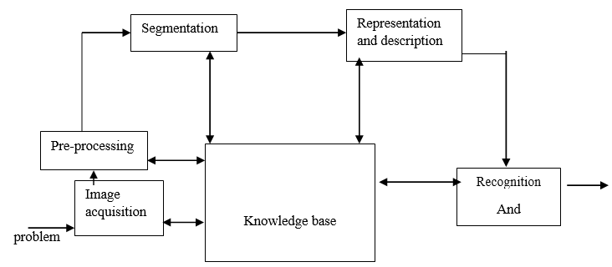

Fig. 1: Fundamental steps involved in Digital Image Processing

4

1. **ALGORITHM USED: ‘VIOLA-JONES’ ALGORITHM**

Paul Viola and Michael Jones presented an approach for object detection which minimizes computation time while achieving high detection accuracy. Paul Viola and Michael Jones proposed a fast and robust method for face detection which is 15 times quicker than any technique at the time of release with 95% accuracy.

**Fundamental steps in VIOLA-JONES method are:**

**Step 1**: Various facial and non-facial images taken.

**Step 2**: The facial images are accepted in initial stages and the non-facial ones rejected.

**Step 3**: The most defining facial feature are extracted in the next stage, while the non-facial features such as the background region is rejected.

**Step 4**: In successive stages, the process is repeated from most-defining to least-defining features and all non-facial features irrelevant to detection are discarded.

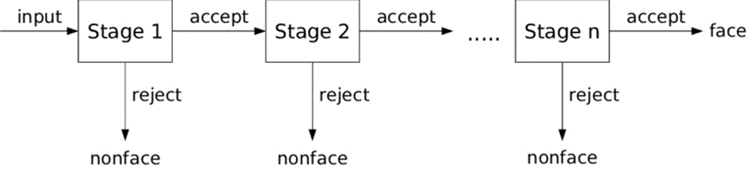

Fig. 2: Sequential process involved in Viola Jones Algorithm

5

1. **SYSTEM DESIGN & METHODOLOGIES**

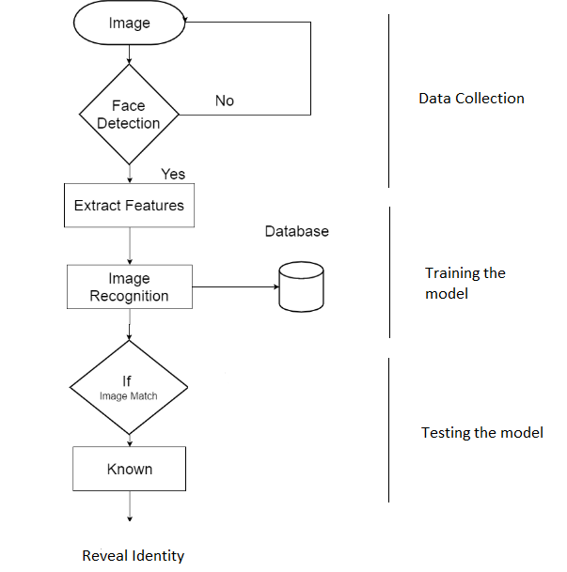

Fig. 3: Diagrammatic sequence of the methodology

The entire process involves three main processes/methods:

* **Data Collection**, where the sample images are taken and forms the data.
* **Training the Model**, where the model is being trained with the collected data images.
* **Testing the Model**, where the model is being tested for successful recognition of the subject based on the training.
  1. Data Collection

Input Algorithm:

**Step 1:** Start.

**Step 2:** The webcam is implemented to turn on.

**Step 3:** Detect presence of face using Viola Jones algorithm (vision.CascadeObjectDetector).

**Step 4:** The model is implemented to train for 50 images for a particular face, c=50.

**Step 5:** A counter is set to track total number of captured images, temp=0.

**Step 6:** On encountering a face, the webcam is implemented to take snapshots.

6

**Step 7:** When temp>=c, no further images are taken.

**Step 8:** The snapped images are then implemented to be consecutively cropped and resized to a set resolution of 227x227.

**Step 9:** The captured images are assigned names according to the numerical counts of the counter starting from 0. The numerical counts are converted to strings (num2str) and .bmp extension is added.

**Step 10:** The temp variable is simultaneously incremented after every image is cropped and resized, until 50 images are achieved.

**Step 11:** If no face is detected, incrementation of temp variable is not viable.

**Step 12:** The path is set to a locally created folder, under an assigned folder_name.

**Step 13:** Run the code.

**Step 14:** End.

* 1. Training the Model

Input Algorithm:

**Step 1**: Start.

**Step 2**: Extract the features of human face using alexnet. Alexnet is a MATLAB function which can identify 1000 objects such as mouse, keyboard, face element etc.

**Step 3**: We train our model with the locally stored image with Stochastic Gradient Decent with Momentum.

**Step 4**: For each pixel we calculate: slope.

**Step 5**: Initially the weight of first pixel is considered as 0. Now we calculate the weight of each pixel.

**w2 = w1 - (learning rate * slope of pixel)**

We considered learning rate as 0.001.

**Step 6**: Repeat the process until we get weight of all pixels for our training images.

**Step 7**: Save the data.

**Step 8**: End.

* 1. Testing the Model

Input Algorithm:

**Step 1**: Start.

**Step 2**: The webcam is implemented to turn on.

**Step 3**: The saved data is loaded.

**Step 4**: Viola Jones algorithm is implemented for face detection (vision.CascadeObjectDetector).

**Step 5**: On encountering a face, the webcam is implemented to take snapshots.

**Step 6**: The detected image is cropped and resized to 227x227.

**Step 7**: We compare the captured image using the saved data and the image is then matched with the training images.

**Step 8**: If match is found, the person is recognised as his name (set the name of the locally saved folder) is printed.

7

**Step 9**: MATLAB Text-Speech Synthesizer function (text-to-speech preloaded synthesizer) is used to speak out the name.

**Step 10**: If the person is not recognised, it is printed: No face detected.

**Step 11**: End.

8

1. **SNAPSHOTS OF RESULTS**

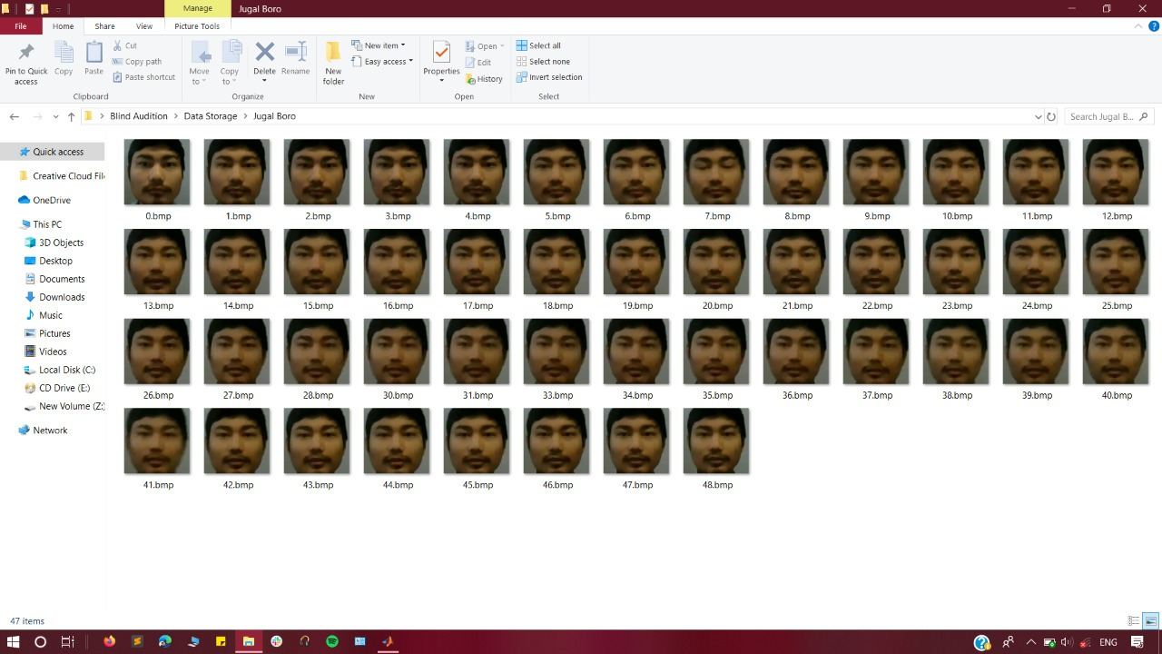

Fig. 4.1: Data collected initially stored in local folder.

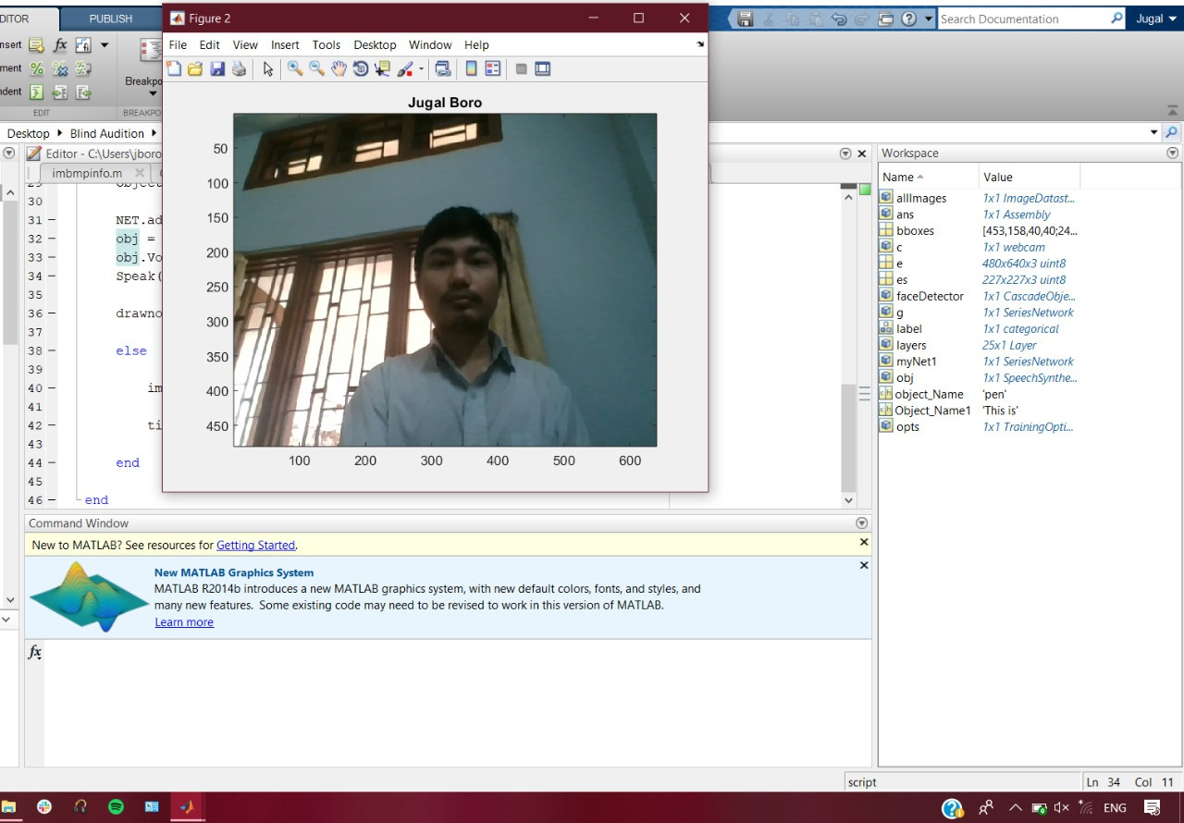

Fig. 4.2: Testing image matching with training image, revealing identity of the person as the local folder name storing the training images.

9

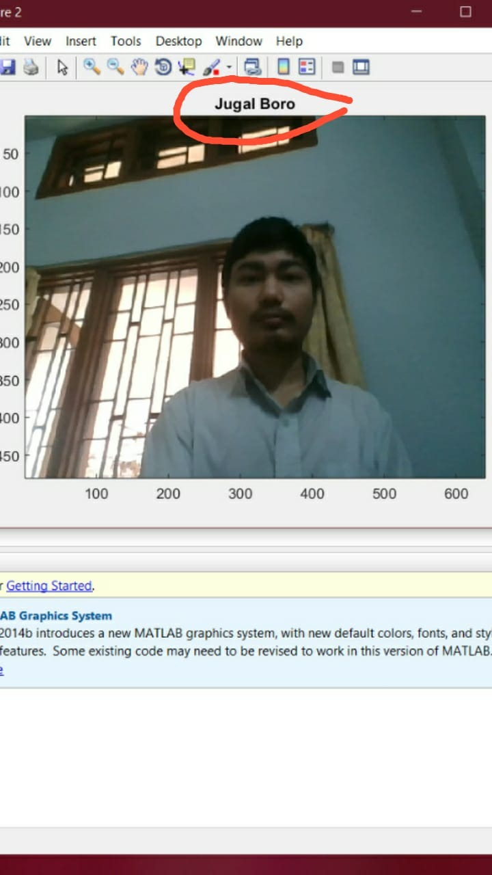

Fig. 4.3: The identity outputted in a speech format.

10

1. **CONCLUSION**

The computational models, which were implemented in this project, were chosen after extensive research, and the successful testing results confirm that the choices made by the researcher were reliable. This system was tested under very robust conditions in this experimental study and it is envisaged that real-world performance will be far more accurate. The fully automated frontal view face detection system displayed virtually perfect accuracy.

Through this project demonstration, we have tried implementing the idea of bringing the vision level of the blind very close to the normal ones. The project demonstrates a software model which enhances participation of the visually impaired by enabling them to be more effective in social interactions.

11

1. **FUTURE SCOPE**

The number of visually impaired people worldwide is approximately 285 million; in other word more than 3.86% of the entire population. There are methods like the Braille which was introduced as an option for studying for the visually impaired people. But this method has two major issues. Firstly, very few books are modified into Braille and secondly only minority of the blind population can read Braille.

So, the purpose of our project will be to design a system for the visually impaired persons to hear text from the books, so that they can read printed books in the same way as the normal users do. We shall utilize the benefits of the ‘Optical Character Recognition’ technology which is used for character recognition by separating the text from the image.

12

1. **REFERENCES**

* WHO. (2014, August) Visual impairment and blindness. Archived at http://www.webcitation.org/6YfcCRh9L. [Online]. Available: http: //www.who.int/mediacentre/factsheets/fs282/en/
* Faizan Ahmad, Aaima Najam & Zeeshan Ahmed (2013), “Image-based Face Detection and Recognition: State of the Art”, IJCSI International Journal of Computer Science Issues, Vol. 9, Issue. 6, No. 1.
* Luke Dormehl, “Facial recognition: is the technology taking away your identity?”, The Guardian, 2018.
* Md. Atiqur Rahman (2021). Face Detection using Viola-Jones Algorithm (https://www.mathworks.com/matlabcentral/fileexchange/50077-face-detection-using-viola-jones-algorithm), MATLAB Central File Exchange. Retrieved January 25, 2021.
* Bhupendra Vishwakarma, Pooja Dange, Abhijeet Chavan, Akshay Chavan, Prof. Hema Galiyal, “Face & Facial Expression Detection,” International Research Journal of Engineering and Technology (IRJET), Vol. 04, Issue 01, p-ISSN: 2395-0072.
* Laxmi Narayan Soni, Ashutosh Datar, Shilpa Datar, “Implementation of Viola Jones Algorithm Based Approach for Human Face Detection,” Semantic Scholar, 2017.
* K Krishan Kumar Subudhi And Ramshankar Mishra “Human Face Detection and Recognition”.
* P. Viola, M. J. Jones, “Robust Real-Time Face Detection”, International Journal of Computer Vision 57(2), 137–154, 2004.
* Baron, R. J. (1981). Mechanisms of human facial recognition. International Journal of Man Machine Studies, 15:137-178.
* Zhiming Qiang, Dan Xu, “Research Advances in Face Recognition,” Chinese Conference on Pattern Recognition, 2009.
* Madan Lal, Kamlesh Kumar, Rafaqat Hussain Arain, Abdullah Maitlo, Sadaquat Ali Ruk, Hidayatullah Shaikh, “Study of Face Recognition Techniques: A Survey,” (IJACSA) International Journal of Advanced Computer Science and Applications, Vol. 9, No. 6, 2018.

13

1. **APPENDIX**

* **vision.CascadeObjectDetector:** The Cascade object detector uses the Viola-Jones algorithm to detect people’s faces, noses, eyes, mouth, etc.
* **num2str:** The num2str function converts a numeric array into a character array that represents the numbers. The output format depends on the magnitudes of the original values.
* **Alexnet:** a convolutional neural network that is 8 layers deep.
* **Stochastic Gradient Decent with Momentum:** It is a method which helps accelerate gradients vectors in the right directions, thus leading to faster converging.

14